# Create K8s Cluster

**Create kubernetes cluster : Using vagrant + shell :**

**Shell Files : We have 1 master and 2 Worker**

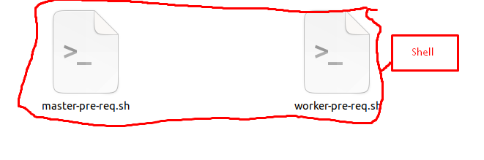

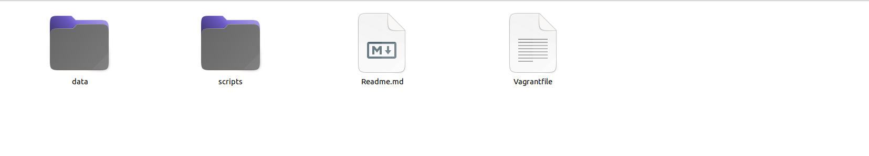

**Vagrant File :**

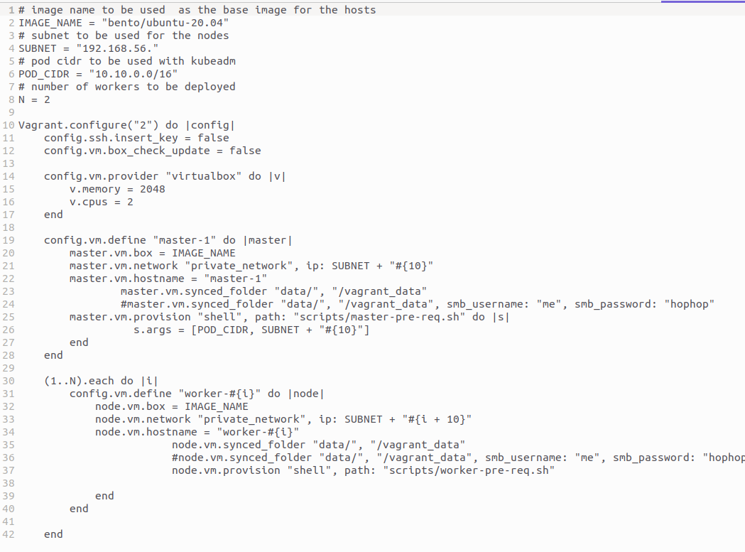



**Master**

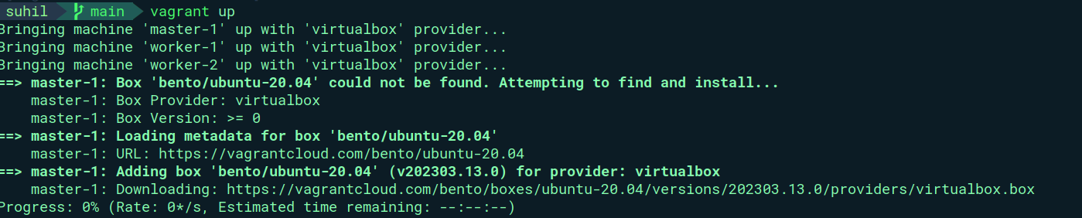

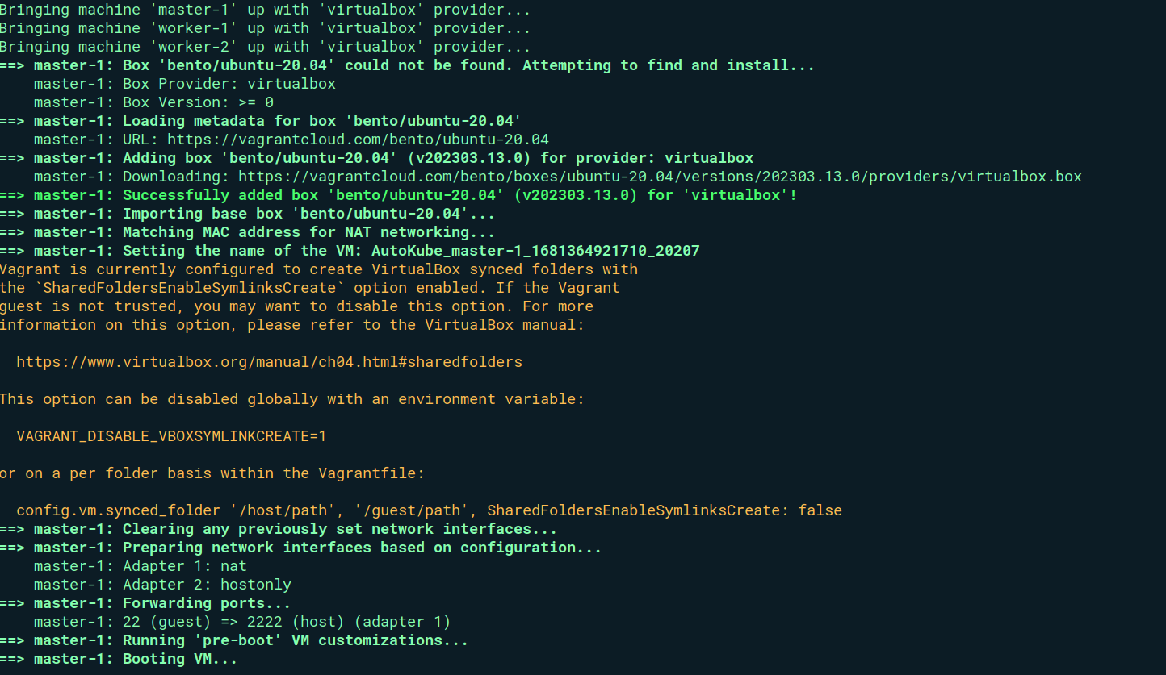

**Worker 1**

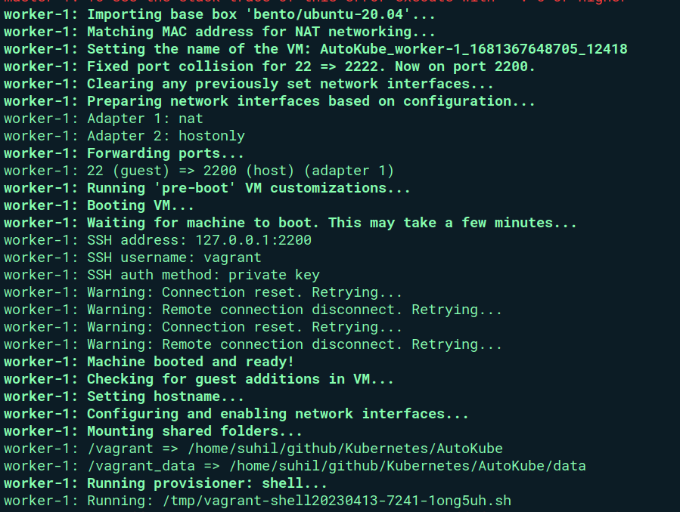

**Worker 2**

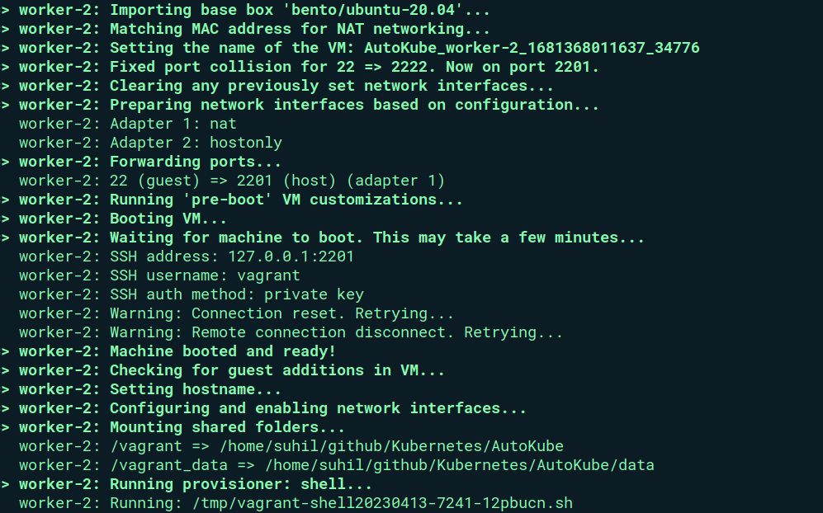

**Up and Running:**

